ASSIGNMENT - 5.5

2303A510G1
Batch : 30

Task Description #1 (Transparency in Algorithm Optimization) Task: Use AI to generate two solutions for checking prime numbers:
- Naive approach(basic) • Optimized approach Prompt:
“Generate Python code for two prime-checking methods and explain how the optimized version improves performance.” Expected Output:
- Code for both methods.
- Transparent explanation of time complexity.
- Comparison highlighting efficiency improvements.

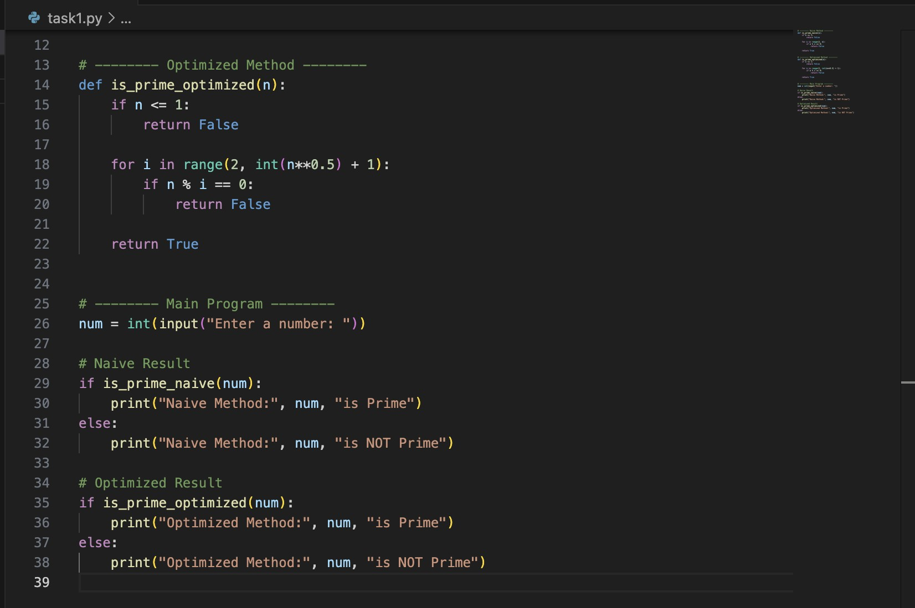

Output:

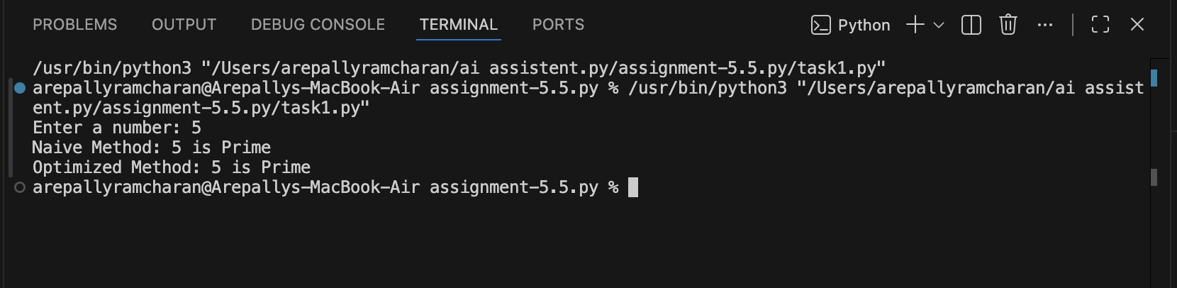
Observation:
  - Naive method checks all numbers from 2 to n-1 → Time Complexity O(n).

  - Optimized method checks only up to √n → Time Complexity O(√n).

  - Both methods give the same correct result.

  - Optimized version significantly reduces iterations for large numbers.

  - Performance improvement becomes more noticeable as input size increases.

Task Description #2 (Transparency in Recursive Algorithms) Objective: Use AI to generate a recursive function to calculate Fibonacci numbers.
Instructions:
- Ask AI to add clear comments explaining recursion.
- Ask AI to explain base cases and recursive calls.
Expected Output:
- Well-commented recursive code.
- Clear explanation of how recursion works.
- Verification that explanation matches actual execution.

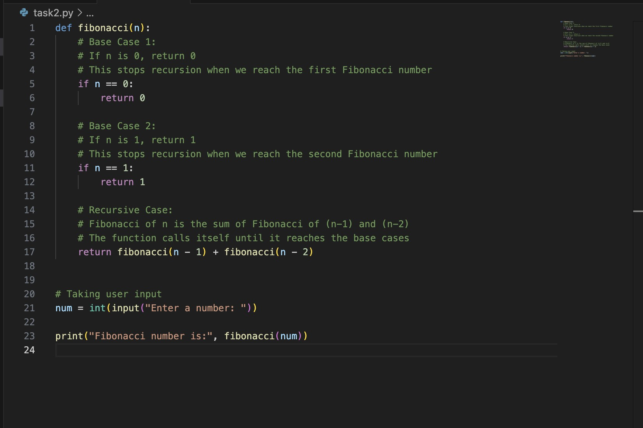

Output:
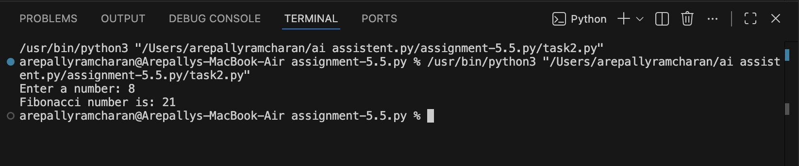
Observation:
The recursive function clearly demonstrates how a problem is broken into smaller subproblems.

Base cases (n == 0 and n == 1) correctly prevent infinite recursion.

Recursive calls follow the mathematical definition of Fibonacci: F(n) = F(n−1) + F(n−2).

The function produces correct results, but it performs repeated calculations.

Time complexity is O(2ⁿ), making it inefficient for large inputs.

Task Description #3 (Transparency in Error Handling)
Task: Use AI to generate a Python program that reads a file and processes data.
Prompt:
“Generate code with proper error handling and clear explanations for each exception.” Expected Output:
- Code with meaningful exception handling.
- Clear comments explaining each error scenario.
- Validation that explanations align with runtime behavior.

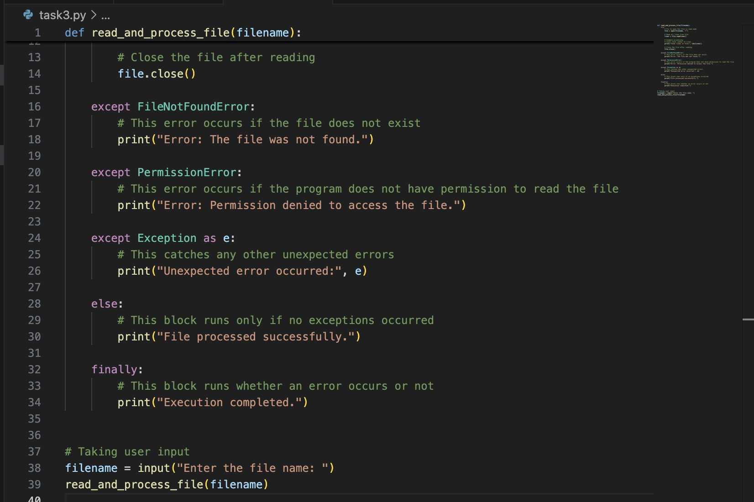

Output:

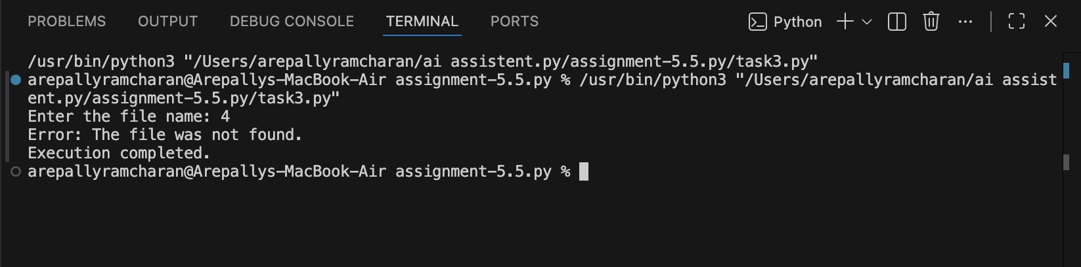
Observation:

  - Program prevents crashes using structured exception handling.

  - Each exception type is clearly separated.

  - Explanations match actual runtime behavior.

  - finally ensures execution completes gracefully.

  - Improves reliability and transparency of file operations.

Task Description #4 (Security in User Authentication)
Task: Use an AI tool to generate a Python-based login system. Analyze: Check whether the AI uses secure password handling practices.
Expected Output:
- Identification of security flaws (plain-text passwords, weak validation).
- Revised version using password hashing and input validation.
- Short note on best practices for secure authentication.

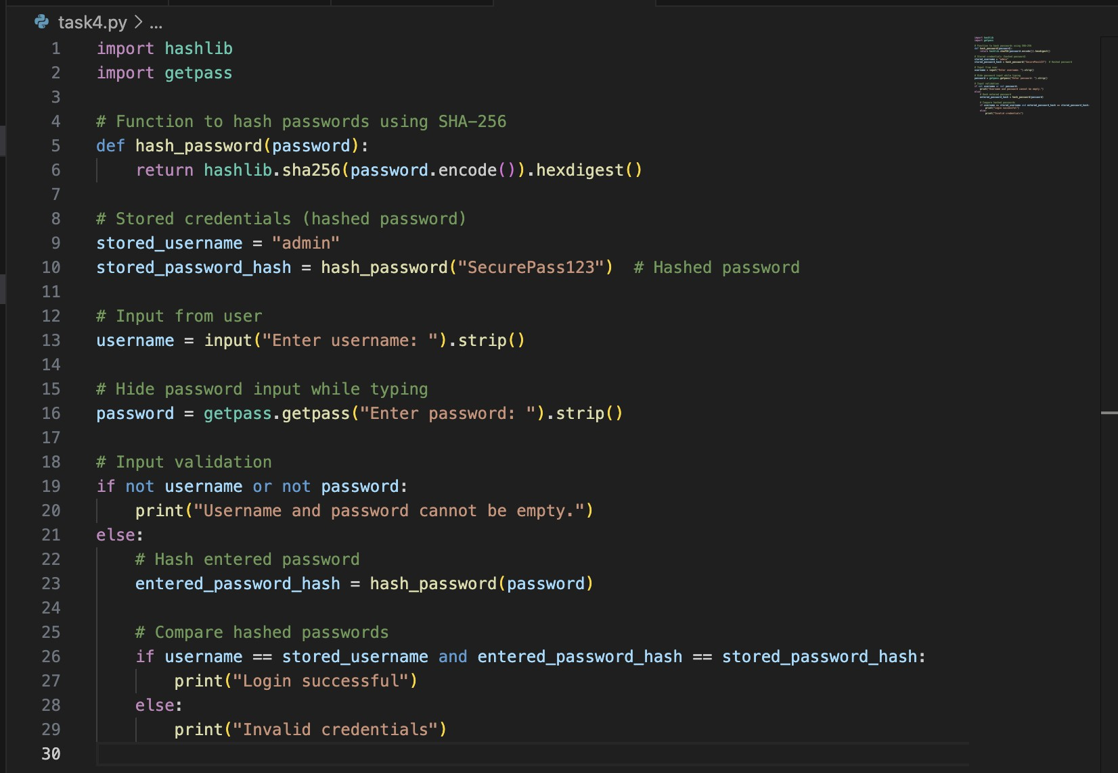

Output:
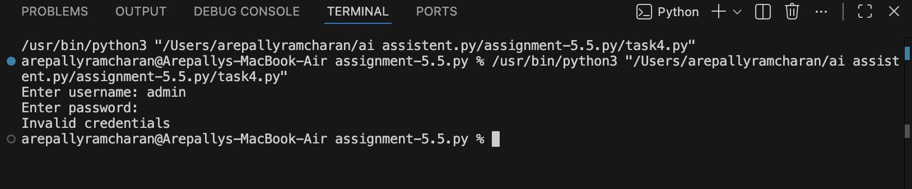

Observation:

Never store passwords in plain text.

Always hash passwords using strong algorithms (bcrypt recommended over SHA-256).

Use salting to prevent rainbow table attacks.

Implement account lockout after multiple failed attempts.

Use HTTPS in real applications.

Validate inputs properly.

Store credentials in secure databases, not directly in code.

Use multi-factor authentication (MFA) when possible.

Task Description #5 (Privacy in Data Logging)
Task: Use an AI tool to generate a Python script that logs user activity (username, IP address, timestamp).
Analyze: Examine whether sensitive data is logged unnecessarily or insecurely.
Expected Output:
- Identified privacy risks in logging.
- Improved version with minimal, anonymized, or masked logging.
- Explanation of privacy-aware logging principles.
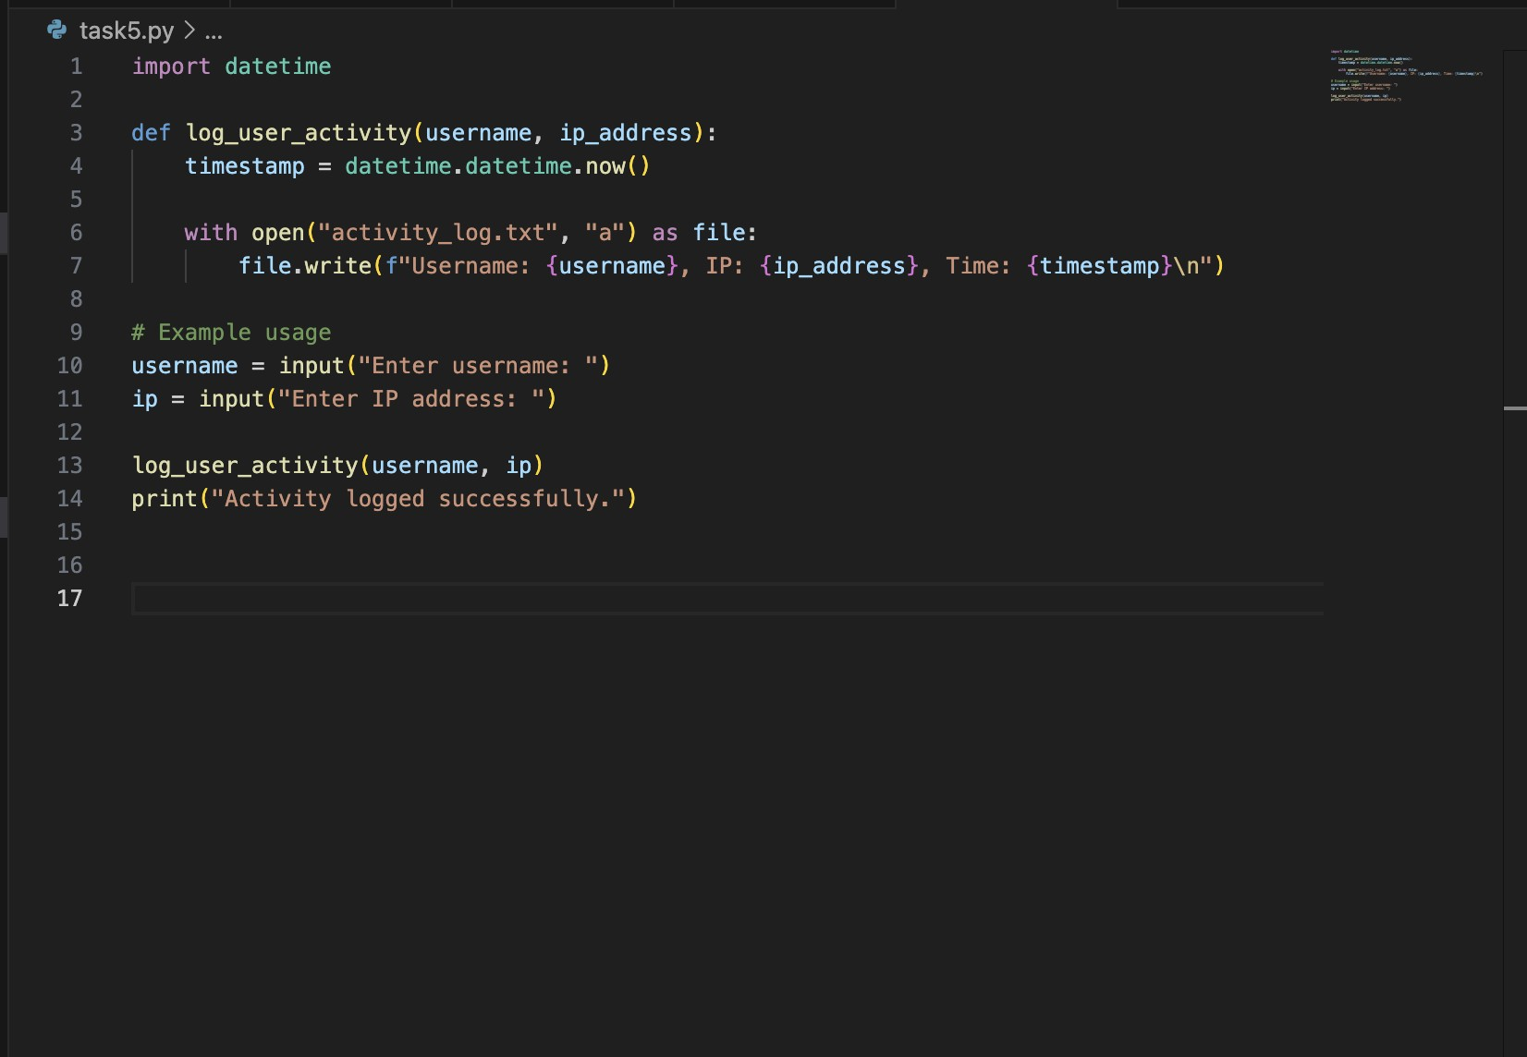

Output:

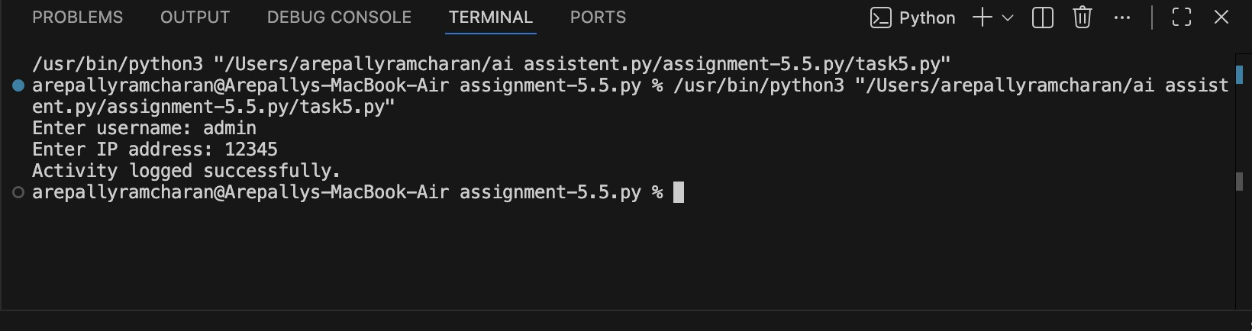

Observation:

Data Minimization

- Log only what is necessary.

- Avoid storing sensitive information.

Anonymization / Pseudonymization

- Hash or mask identifiers.

Access Control

- Restrict who can access logs.

Encryption

- Encrypt log files at rest.

Retention Policy

- Delete logs after defined period.

Transparency

● Inform users about logging practices.

